**GIT AND GITHUB – 02**

**NAME: RAKESH – 15**

1. **Create a GitHub account**

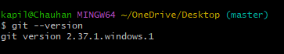

* I have installation on my windows

1. **Set up MFA (Multi-Factor Authentication) for the GitHub account using a mobile app**

* Go to GitHub
* Click on right side settings, select password and authentication
* Click on enable two -factor authentication
* Scan the QR code from MS Authenticator app from mobile
* Enter the code which is shown on mobile app
* Download the recovery codes file for recovery

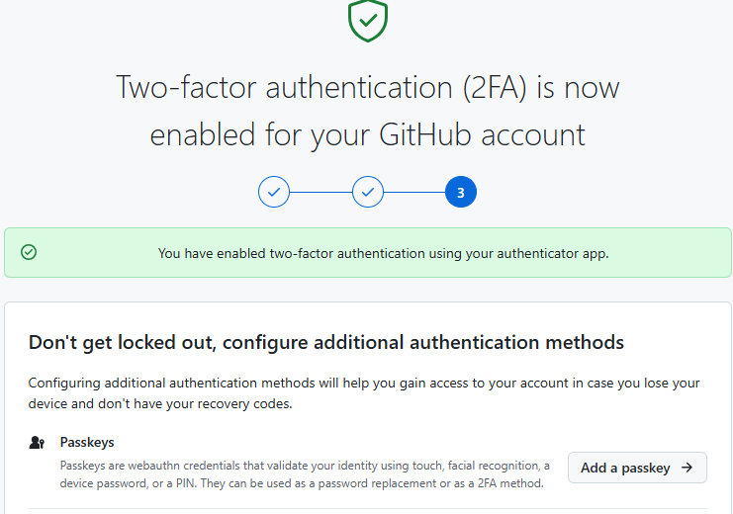

1. **Execute all commands shown in the video**



* Check the version of the git using git --version command

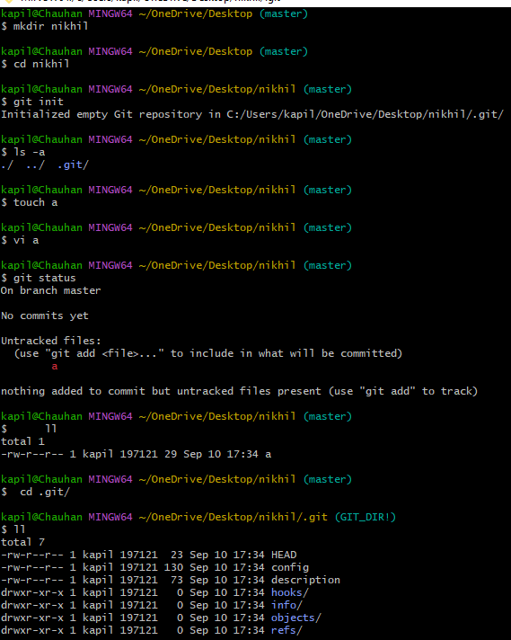

* Create the directory
* Go to the directory
* It initializes a new Git Repository in your current directory and allowing you to start   
  tracking changes to files
* Using **.git/** this directory contains all configuration related to git what is branch what is tail to track the changes the git will not work without this directory

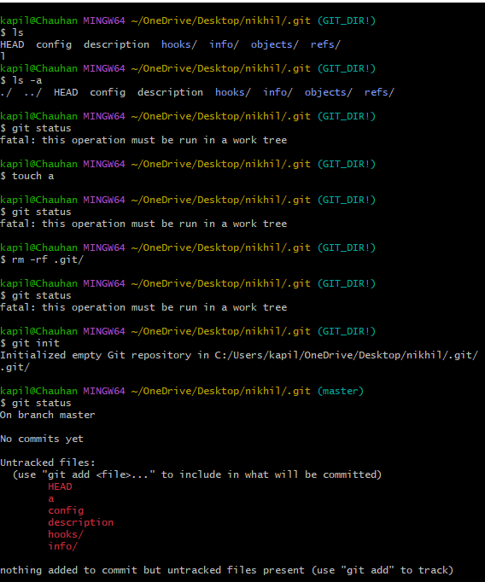

* Here, **git status:** check the status of file is tracked or not

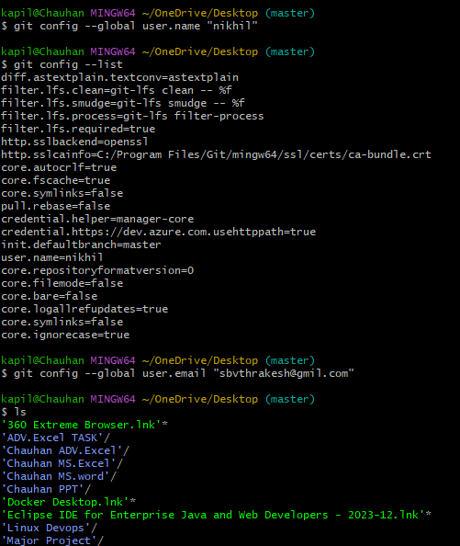

* **Git config --global user.name “nikhil” :** to add the user name
* **Git config –list:** To check the username is added
* **Git config --global user.email “sbvthrakesh@gmail.com”:** to add the gmail

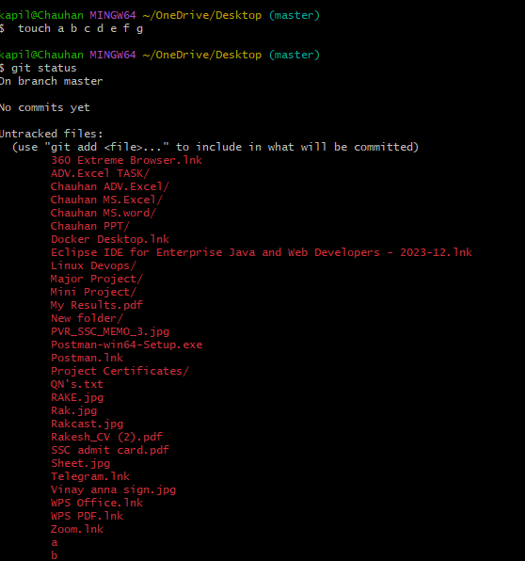

* **Git add** nikhil has a filename
* Create multiple files using **TOUCH** command

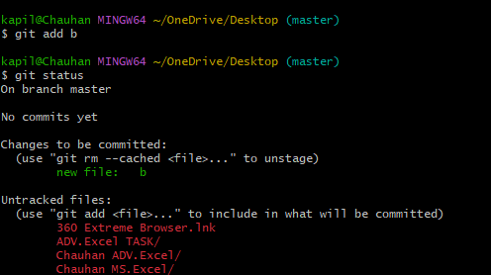

* **Git add .** is add multiple files to the git.

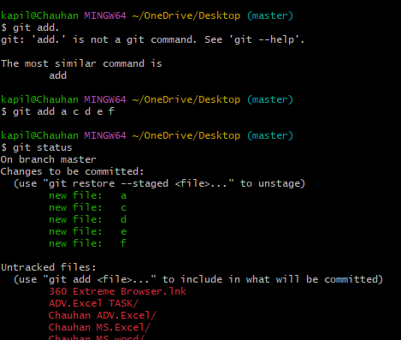

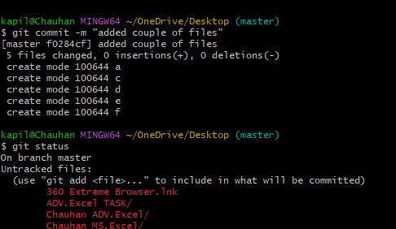

* **Git commit -m “messege”:** It will store a copy in your machine

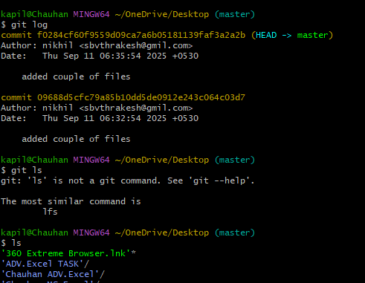

* **Git log:** To see commit ID (commit message ,username , user email, date & time)

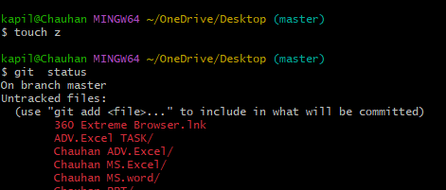

* Create a another file.**Z using Touch command**
* **Z** is in untracked area **using Git status**

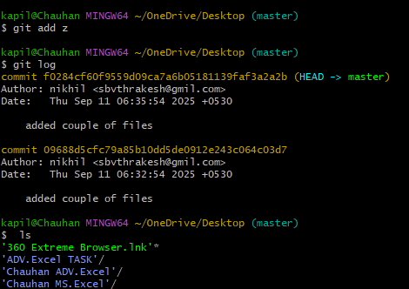

* Here add Z to get commit
* We see there are two different commits
* Go to git hub create new repository to push all the files to repository.
* Copy the url to remote access the repositotry.

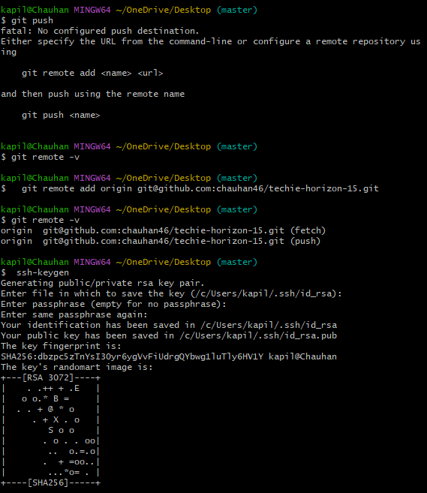

* **Git remote –v:** It shows any address
* Copy the ssh github link
* **Ssh-keygen:** To generate the ssh key generation

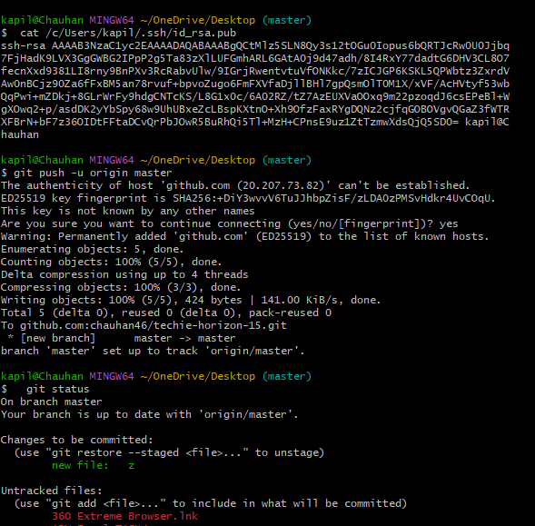

* **Cat /c/users/kapil/.ssh/id_rsa:** While we generate ssh-keygen we get the public key, Copy it and paste on ssh key on Github
* **Git push –u origin master:** This command is to understand to which branch we are trying to push
* Here delete the file **Z**

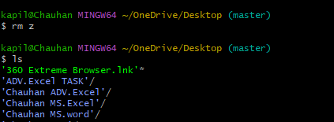

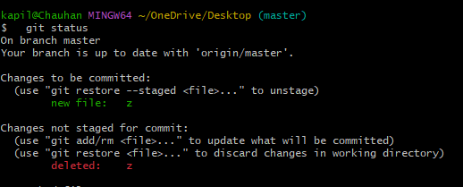

* **Git status:** to check the deleted file

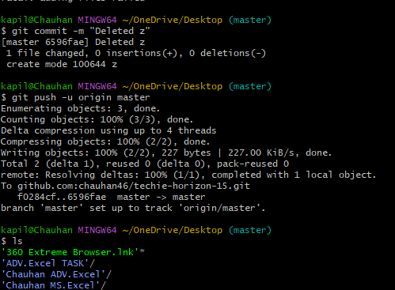

* **Git push –u origin master:** This will try to update your Central repository
* Go to GitHub and go to addfile
* Create a new file there and name the file
* Commit changes
* Then one more file is added

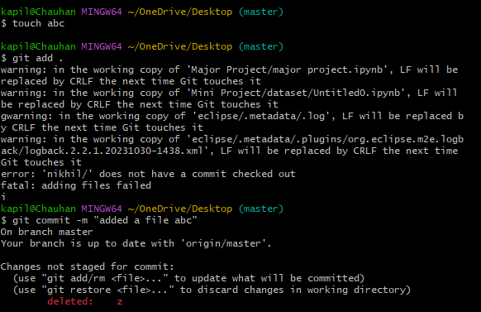

* Add a file using **TOUCH** command

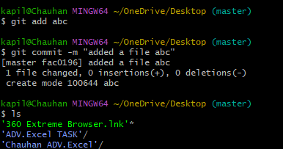

* **Here git commit –m “added a file abc”:** It shows the changed file

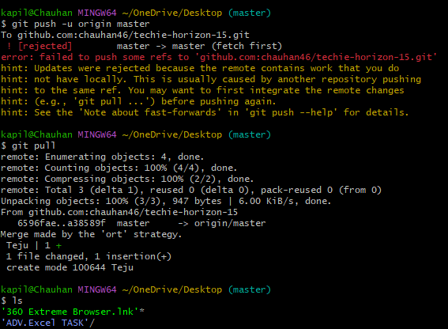

* **Get pull:** Local to Central machines, it will try to pull the changes

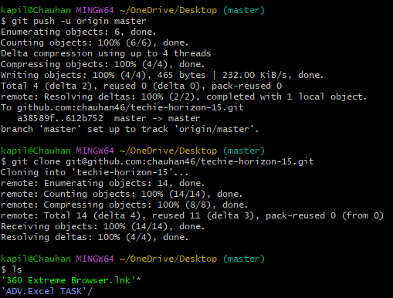

* **git clone** [**git@github.com:chauhan46/techie-horizon-15.git**](mailto:git@github.com:chauhan46/techie-horizon-15.git)**:** It downloads the hole repository instead of latest modify files

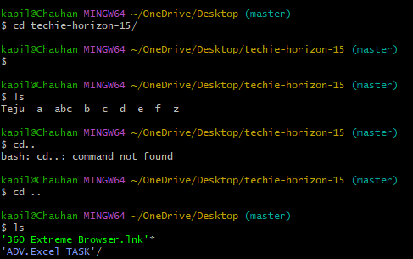

* Here u can see all the files from the repository